Chapter 7 Linear motion
Chapter test answers Total marks 46
Section A
Question 1
B (2 marks)
Question 2
B. 251 × = 69.666 ≈ 69.7 m s^{–1} (2 marks)
Question 3
C. Defining east as positive:
Δv = v – u
= –6 – 7
= –13
Hence Δv = 13 m s^{–1} west. (2 marks)
Question 4
C. Reading from the vertical axis, at t = 60 s, x = 200 m. (2 marks)
Question 5
D. The speed is given by the gradient of the graph at this time.
= –16.666
≈ 17 m s^{–1} in the opposite direction (i.e. returning back towards the property). (2 marks)
Question 6
D. The farmer travelled 500 m forwards, then 500 m back to his original position, then 200 m further back: a total of 1200 m. (2 marks)
Question 7
A. Average velocity = = v_{av} = = 3.3 m s^{–1} back towards the property (2 marks)
Question 8
A. Given u, v and t, find a using v = u + at. (2 marks)

Section B
Question 9
a 72 km h^{–1} = = 20 m s^{–1} (1 mark)
(1 mark)
b Let total distance = s₁ + s₂ where s₁ = ut + 0.5at² and s₂ = vt (1 mark)
s₁ + s₂= (0 + 0.5 × 4.0 × 5²) + (20 × 15) (1 mark)
= 50 + 300 (1 mark)
= 350 m
c

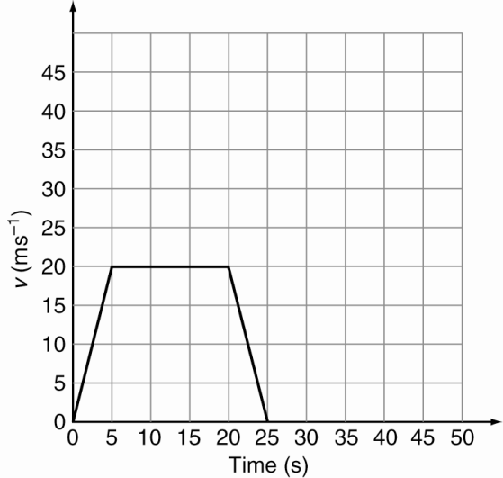
1 mark per section correctly drawn (3 marks)
Answer is consequential: gradient for first 5 s is equal to the answer to part a.
Horizontal section from t = 5 to t = 20 s is a conversion of 72 km h^{–1} to 20 m s^{–1}.
d v_{av} = (1 mark)
=
= = 16 m s^{–1} (1 mark)
Answer is consequential: v_{av} =.

Question 10
a (1 mark)
b u = 7.50 m s^{–1}, a = 0, t = 0.590 s, s = ? (1 mark)
s = ut + at²
= 7.50 × 0.590 = 4.43 m (1 mark)
c u = 7.50 m s^{–1}, a = –2.50 m s^{–2}, v = 0.00 m s^{–1}, s = ?
use v² = u² + 2as (1 mark)
s0 = 7.50² + 2 × –2.50 × s
(1 mark)
d add distances from parts b and c = 4.43 + 11.3 = 15.7 m (1 mark)
Question 11
a a = g = 9.80 m s^{–2} downwards (1 mark)
b Analysing the rise only: u = 20.0 m s^{–1}, a = –9.80 m s^{–2}, v = 0 m s^{–1}
v = u + at (1 mark)
0 = 20 – 9.80t
–20 = –9.80t
t = 2.04 s (1 mark)
Therefore total time in the air is (2 × 2.04) = 4.08 s
c a = g = 9.80 m s^{–2} downwards at all stages of the flight (1 mark)
d Analysing the rise: at max height v = 0, a = –9.80 m s^{–2}, u = 20.0 m s^{–1}
v² = u² + 2as
0² = 20² + 2 × –9.80 × s (1 mark)
–400 = –19.6 s
s = 20.4 m (1 mark)
e Since there is no air resistance, the speed is the same on the way down as the way up at equivalent heights, so v = 20.0 m s^{–1}. (1 mark)
Question 12
a Taking up as positive:
u = 30.0 m s^{–1}
s = –40.0 m (1 mark)
a = –9.80 m s^{–2}
v² = u² + 2as (1 mark)
= 30.0² + 2 × (–9.80) × (–40.0)
= 1684
v = 41.0 m s^{–1} (1 mark)
b v = u + at
t =
= (1 mark)
= 7.24 s (1 mark)
c At the top, u = 0.00 m s^{–1}. (1 mark)
v² = u² + 2as
41.0² = 0² + 2 × –9.80 × s
s = –85.8 m
The stone fell 85.8 m to the sea from the maximum height. (1 mark)

